LOCAL INITIATIVE FOR INTEGRATED DEVELOPMENT
Website: www.ildi-rdc.org
Summary of ILDI's success during its six years of implementing the TTAA project.

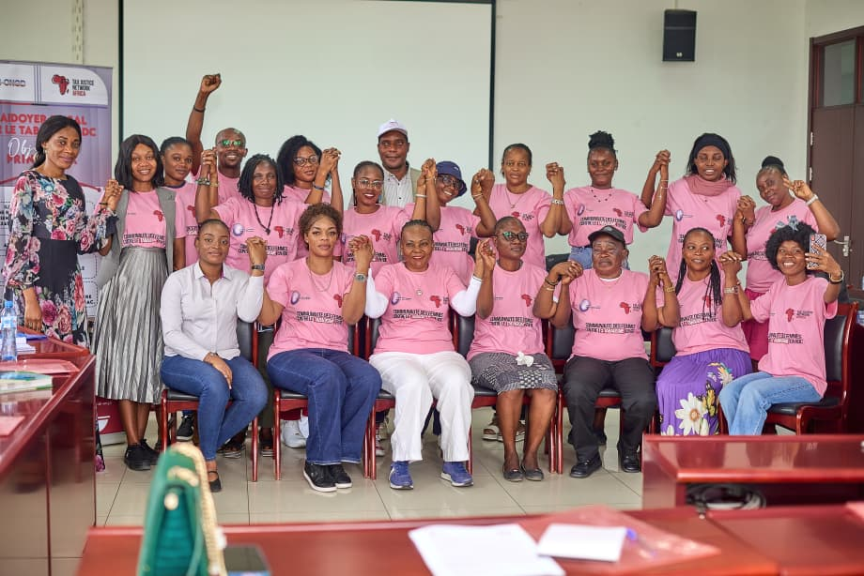
In 2005, the Democratic Republic of Congo (DRC) signed and ratified the World Health Organisation Framework Convention on Tobacco Control (WHO FCTC), thereby committing to safeguard current and future generations from the tobacco epidemic and to promote sustainable development. Since 2017, the Local Initiative for Integrated Development (ILDI) has been implementing the Tobacco Tax Advocacy Project in Africa (TTAA).
Continuing our advocacy commitment in the second phase of the project, our focus is on gradually increasing the excise tax rate on tobacco and nicotine products, as well as changing the tobacco tax structure by shifting to a mixed structure in line with WHO recommendations. These efforts have so far yielded the development of a simulation model. The model examines the effects of tobacco taxation in the DRC, an effective advocacy tool designed to inform government decisions on tobacco taxation. Leveraging on the simulation results and advocacy undertaken by ILDI and other stakeholders, on December 20, 2024 DRC’s President promulgated a 2025 finance law that increased excise duties on cigarettes from 60% to 100%, plus a special excise duty of 20% (lf_2025_depenses.pdf).
This is a firm commitment by the DRC government to protect its population from non-communicable diseases linked to tobacco and nicotine consumption and to mobilizing national resources through tobacco taxation.
Nevertheless, to further strengthen the tobacco and nicotine control policies, we specifically call on government authorities, parliamentarians, and relevant national and international partners to pursue the following reforms in the sector:
- Estimated at almost 85% (https://ildi-rdc.org/wp-content/uploads/2025/11/Etude_du_commerce_illicite_du-tabac_Version-finale-ILDI-2.pdf), the illicit tobacco trade is a major problem and a hindrance to tobacco control efforts in the DRC. It is necessary and urgent to vote on the bill authorizing the ratification of the WHO protocol to eliminate nearly 80% of the illicit tobacco trade in the DRC.
- To switch, from an ad valorem system to a mixed system (ad valorem & specific) on cigarettes. This is to simplify the tax structure, make it effective in mobilizing revenue, and prevent manipulation by the tobacco industry.
ILDI Team
Godefroid MBOYO
Project Manager.

